Document Name | Cemetery Management System Phase 2 – Design Phase
Version | 1.0
Author | Geoilocate Team
Date | 02 September 2016

Content

1. Introduction

After the Cemetery Management System Analysis phase, we will now look at how the system should implement the required solution. The design phase document shows the transformation of the requirements into a complete and detailed system design specification.

2. Purpose

a. To describe the system functions and features in details.
b. To describe user interface that will allow end users to operate the system and its functions.
c. To provide user manuals.
d. To show database infrastructure.

3. Scope

These standards lay down the purpose and content of the following manuals.
- System manual.
- Reference manual

These standards and manuals will be used by application development team as well as application maintenance team in preparation and revision of implementation documents.

4. Intended Audience

This system will be used by members of the Buffalo City Metropolitan Municipality Cemeteries staff.

5. Known Issues

a.The BCMM Cemetery team is currently using manual process, might experience resistance to change.
b.The BCMM Cemetery division/processes includes other divisions in the BCMM and outside BCMM which will not be part of the system (i.e Cashiers, Exhumation process)

6. Implementation Plan Coordination

a. The system will be hosted by .....
b. The BCMM Cemetery team are the ones who will be trained on how to use the system.

7. System Overview

The CMS is aimed at assisting the Cemetery team to manage their documents online. The system will allow the Cemetery team to store, update, and retrieve customer information. Certain information will be avaible to the public and other information will only be seen by BCMM Cemetery staff with different privileges.The system will have simple user interface to allow users with minimal computer skills to learn it fast and easy. It will assist in minimizing manual file keeping and it will also minimise paperwork carried throughout the BCMM.

8. System Authorization
The public will be able to search for some of the information and only authorized Cemetery staff will be given right to view/edit and delete information. Should the system require any changes or updates, Geoilocate will be responsible for carrying out the BCMM request. The system is owned by Geoilocate and may not be used or referenced without their concern.

9. System manual

Table of Content
- Purpose
- Software inventories
- List of Screens
- Screen Layout
- List of Reports
- Report Layout
- System constrains and Limitations
- Users and their roles.

Purpose
The purpose of the system manual is to provide an overview of the system by listing out in brief how the system works , how data is sent and retrieved from the database etc. Reader interested in a specific section may refer to the corresponding manual.

The major readers of the system manual are the administrators responsible for managing the system.

Software Inventories
User interfaces

10.1 List of Screens
- Public Home Page
- Login Page
- Register Page
- Authorized Users Home Page
- Burial of Grave
    - Burial Register
    - Burial Register Forms & Requirements
- Burial of Ashes
    - Ashes Register
    - Ashes Register Forms & Requirements
- Cremation Process
    - Cremation Register
    - Cremation Forms & Requirements
- Exhumation Process
    - Exhumation Register
    - Exhumation Forms & Requirements
- Lease of Grave Site
- Calendar
- Cemeteries Aerial Photo
- Cemeteries Map
- Reports
- Public Home Page
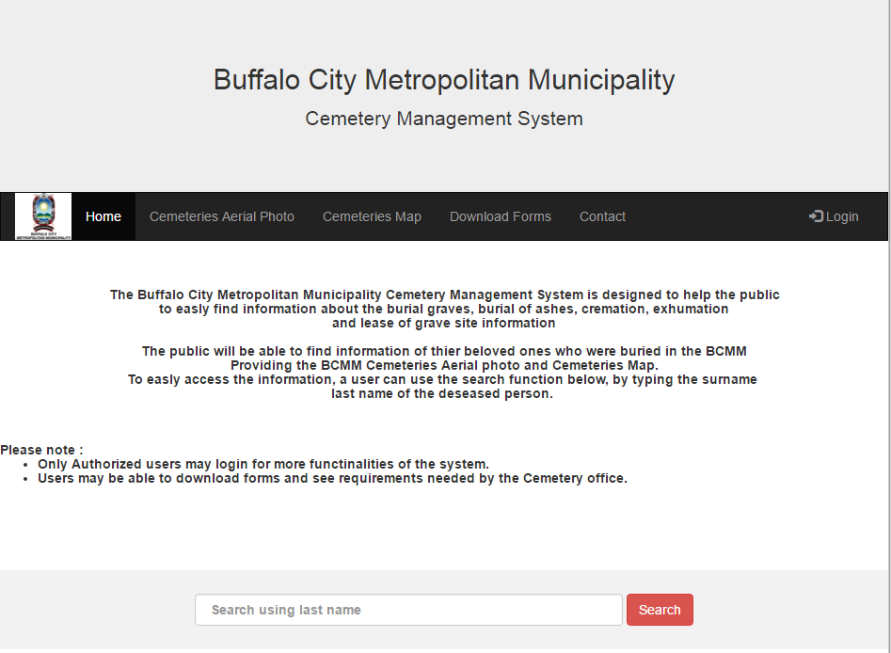

This is a public home page, it will be a link known to the public. There will be no login requirements needed. This will assist the public in
- Searching for burial, ashes, exhumation or cremation information of their late loved ones.
- See available grave plots.
- Download burial, ashes, and exhumation or cremation forms.
- Knowledge of requirements needed for any cemetery service that might need.
- Be able to send more queries to the BCMM Cemetery team.

- Login Page
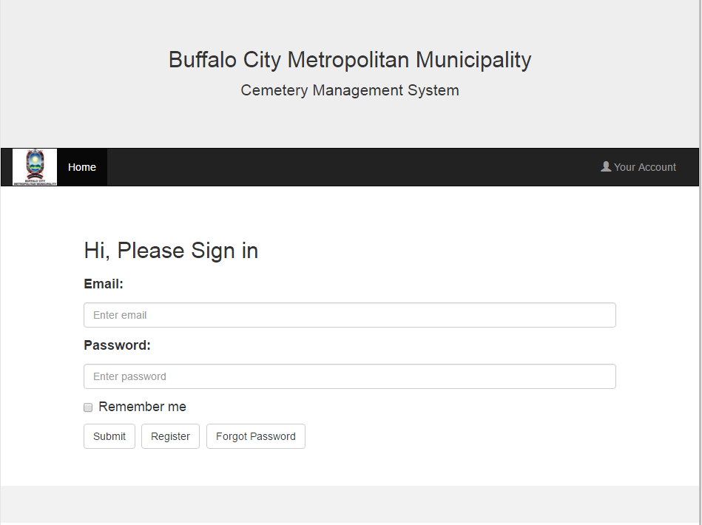

Login Screen will allow authorised or registered users to login into the system to be able to perform more functions.
** to remove register button**

- Register Page
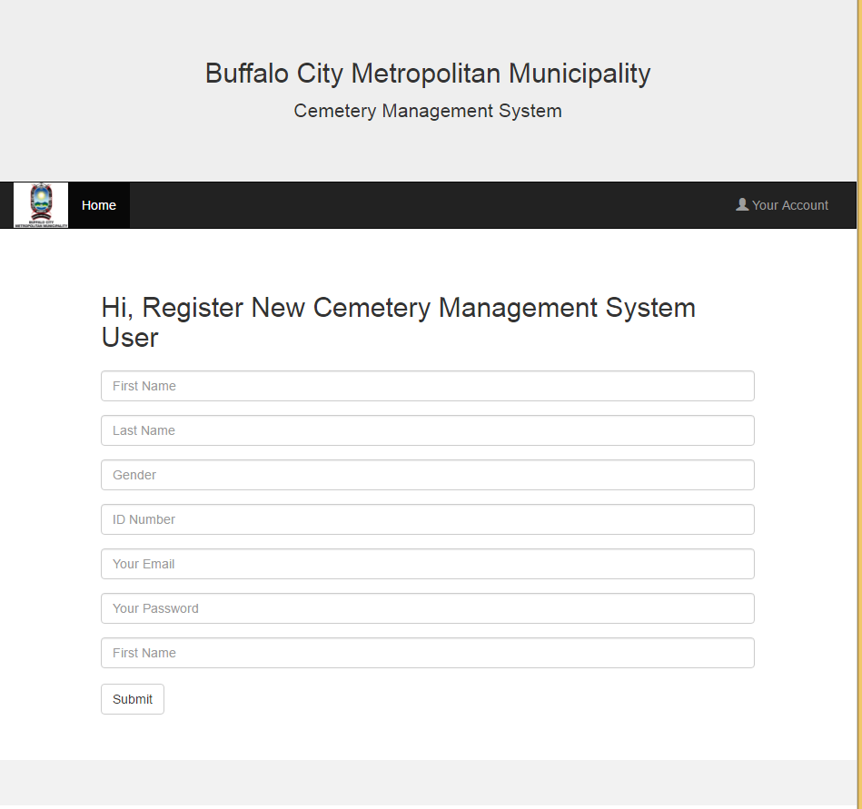

The register page will only be available to the super user/master administrator who will be responsible in adding new users.
**still to confirm fields to have**

- Authorized Users Home Page
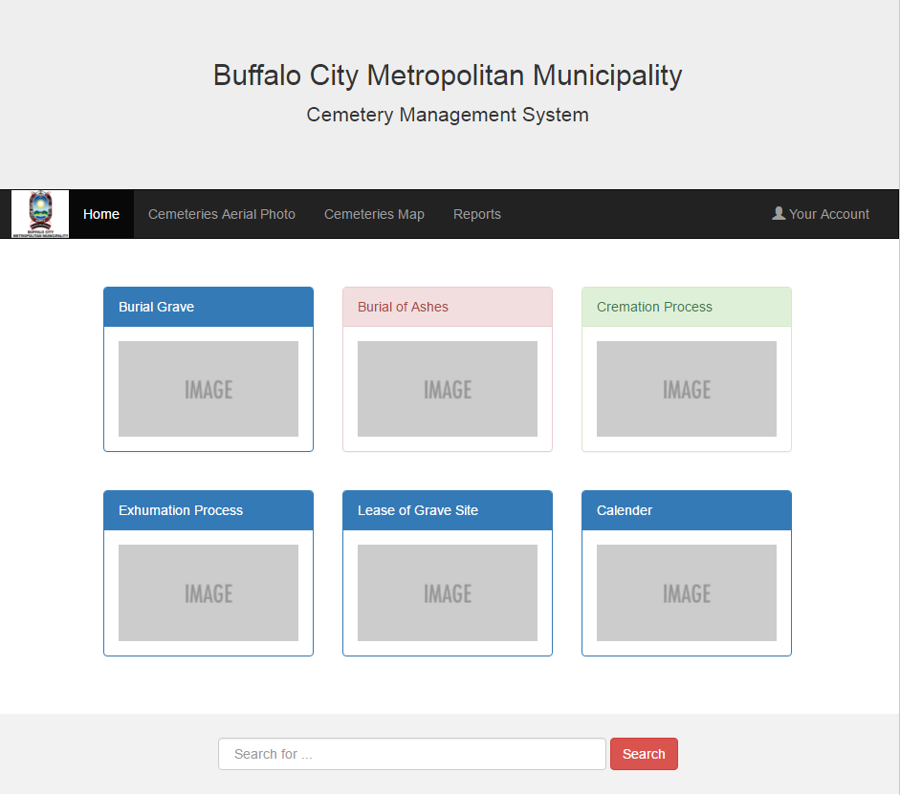

Registered users may login and be able to view the authorized user home page. Users of the systems will also be given different privileges to the system.

- Burial of Grave
    - Burial Register
    - Burial Register Forms & Requirements
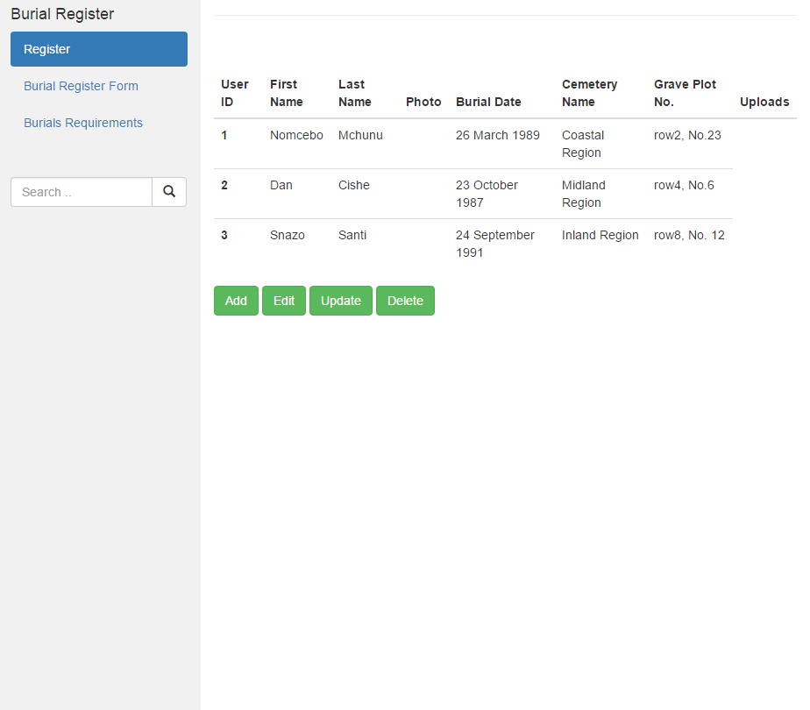

- Burial of Ashes
    - Ashes Register
    - Ashes Register Forms & Requirements

- Cremation Process
    - Cremation Register
    - Cremation Forms & Requirements

- Exhumation Process
    - Exhumation Register
    - Exhumation Forms & Requirements

- Lease of Grave Site

- Calendar

- Cemeteries Aerial Photo

- Cemeteries Map

- Reports

List of Reports

Reports Layouts

11. Systems Constrains and Limitations
11.1 Systems protocols for users.

- The master administrator is granted access to the entire system.

12. Users and their roles

Master Administrator
Description: This is a person that is granted full access to the system. Read/write rights and is mainly responsible for maintaining the system.

Role :
- Register new users

Administrator/Clerk
Description: This is a person who acts as an assistant to the master administrator.

Role:
- Fills/load/add customer information into the system
- Make booking for burials, ashes and cremations
- Update the burial, ashes, cremation and exhumation register.
- Search for customers information
- Upload supporting documents of applications.

Supervisor
Description: This is a person who monitors the system, and can be regarded as a master administrator.

Role:
- Register new users
- View/download medical documents of the deceased.
- Update the burial, ashes, cremation and exhumation register.
- Submit/Send ashes and cremation certificates to customers.

Reference manual

Table of Content

- Introduction
- Purpose
- Application Installation
- System Requirements
- Database Administration
- Database Tables
- Data Dictionary
- Major System Functions

Introduction

This reference is meant for use of maintaining and supporting the system. It is intended for programmers who will be updating the system.

Purpose

Should there be a need to upgrade and fix bugs on the system, troubleshoot the system, the programmers responsible for the system will use this manual to make necessary changes to the system.

Application Installation

The application will be hosted to its domain.

System Requirements

It is highly recommended that the system should be run on the Google chrome browser.

Database Administration

Database Tables

- Login
- User
- Cemeteries
- Blocks
- Grave_Sections
- Burials
- Space
- Buildings
- Networks

Data Dictionary

- tblLogin
Field Name | Type | Null | Default | Description
user_id
email_address
password

- tblUser
Field Name | Type | Null | Default | Description
user_id
first_name
last_name
ID_number
gender

- tblCemeteries
Field Name | Type | Length | Description | Field Name
gid serial | Integer | 10 | This is the unique identifier of an object in the shapefile. | gid serial
cemetery_id  PK | Integer | 10 | This is a unique identifier (number) of a particular cemetery. | cemetery_id  PK
cemetery_name | Character varying | 50 | The name of a particular cemetery. | cemetery_name
town_name | Character varying | 50 | The name of the town that the cemetery is located in. | town_name
municipality | Character varying | 50 | The name of the municipality in which the cemetery is under management. | municipality
type | Character varying | 8 | Whether the cemetery is 'Formal' or 'Informal'. | type
geom | Geometry | NA | The shape of the features in the shapefile. | geom

- tblBlocks
Field Name | Type | Length | Description | Field Name
gid serial | Integer | 10 | This is the unique identifier of an object in the shapefile. | gid serial
block_id  PK | String | 50 | Combination of section name and block name. | block_id  PK
section_id  FK | String | 50 | The name of a particular section within a cemetery. | section_id  FK
block_name | String | 10 | Name given to a block within a section, by the cemetery. | block_name

- tblGrave_Sections
Field Name | Type | Length | Description | Field Name
gid serial | Integer | 10 | This is the unique identifier of an object in the shapefile. | gid serial
section_id  PK | Character varying | 50 | The name of a particular section within a cemetery. | section_id  PK
cemetery_name | Character varying | 50 | The name of a particular cemetery. | cemetery_name
cemetery_id  FK | Integer | 10 | This is a unique identifier (number) of a particular cemetery in the BCMM. | cemetery_id  FK

- tblBurials
Field Name | Type | Length | Description | Field Name
gid_serial | Integer | 10 | This is the unique identifier of an object in the shapefile. | gid_serial
burial_plot_id  PK | Numeric | 50 | A number assigned to each burial plot in a cemetery. | burial_plot_id  PK
block_id  FK | String | 15 | Combination of section name and block name. | block_id  FK
burial_id  FK | Character varying | 10 | Unique grave identifier allocated by cemetery. | burial_id  FK

- tblSpace
Field Name | Type | Length | Description | Field Name
gid serial | Integer | 10 | This is the unique identifier of an object in the shapefile. | gid serial
burial_plot_id  PK & FK | Numeric | 50 | A number assigned to each burial plot in a cemetery. | burial_plot_id  PK & FK
block_id | String | 50 | Combination of section name and block name. | block_id
availability | Text | 3 | An indication of spaces available. (yes/no) | availability

- tblBuildings
Field Name | Type | Length | Description | Field Name
gid_serial | Integer | 10 | This is the unique identifier of an object in the shapefile. | gid_serial
building_name  PK | string | 50 | name of the building. | building_name  PK
cemeterty_id  FK | integer | 10 | this is a unique identifier (number) of a particular cemetery in the bcmm. | cemeterty_id  FK
cemetery_name | string | 20 | name of the cemetery in which the building is situated. | cemetery_name

- tblNetworks
Field Name | Type | Length | Description | Field Name
gid_serial | Integer | 10 | This is the unique identifier of an object in the shapefile. | gid_serial
name  PK | Character varying | 50 | name of the network route. | name  PK
cemeterty_id  FK | Integer | 50 | name of the cemetery in which the building is situated. | cemeterty_id  FK
geom | Geometry | NA | the shape of the features in the shapefile. | geom

Major System Functions

13. Conclusion

14. Abbreviations

Acronym | Description
CMS | Cemetery Management System
BCMM | Baffalo City Metro Municipality
EHS | Environmental Health Section
COGTA | Co-Operative Governance Traditional Affairs
GIS | Geographical Information System

